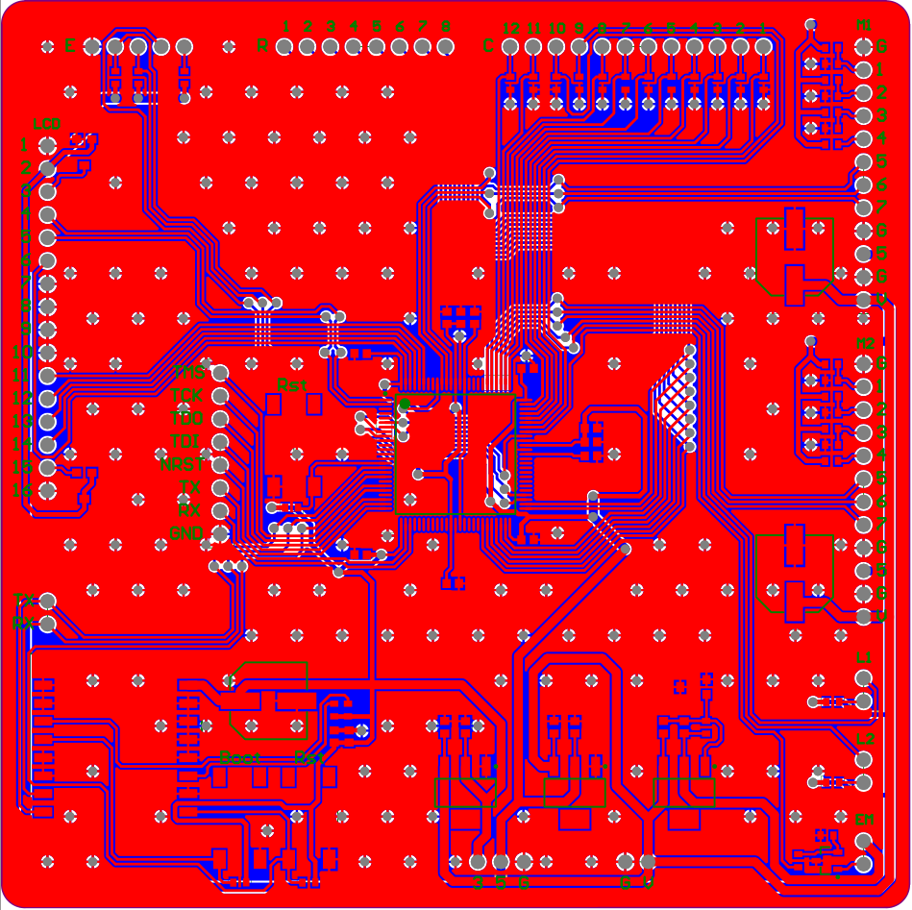

*From left to right: Maurice Wallace, Mark Mauriello, Nicholas Kraus, Kyle Jameson.*

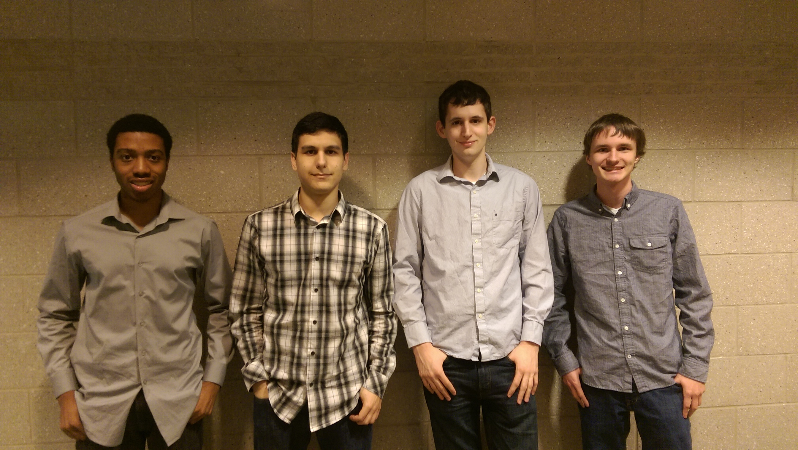

**Team 5: WiFi Connected**

**Chess Board**

*Sponsored by: Team members*

*Faculty Advisor: Yufeng Wu*

**COMPUTER SCIENCE & ENGINEERING**

LOGO GOES HERE

Logo should be a color, high resolution JPG and placed in the location shown above by the blue rectangle. Blue box is to show you location and size only. Please delete it once you place the logo

OTHER PHOTO GOES HERE

Photo should be a color, high resolution JPG and placed in THIS location shown by the blue rectangle. Blue box is to show you location and size only. Please delete it once you place the photo

The problem we aimed to solve was simple: how do you play chess online with a friend and still keep the charm and ease-of-use of having a physical chess board in front of you? The result is a physical chess board that can connect to the internet via WiFi. Like a normal game of chess, each player takes turns moving their pieces on the board. Our board then reads the move the player makes, translates the move into an encoded message, and sends the message to the opposing player’s board. With that message, the board automatically moves the pieces into place.

Each board consists of a microcontroller, a WiFi module, and an XY gantry underneath the surface of the board. The microcontroller is responsible for driving the motors and gantry that move pieces. Each piece contains a small magnet, which trigger small Reed sensors that reside just underneath every square. Since every game of chess can be defined entirely by its current state, this allows the microcontroller to know where every piece is at any given time.

The two boards both connect to a server, which is in charge of managing the connection, judging the legality of moves, relaying movement messages, and keeping track of the game state. The server was programmed in Python and can run on any modern laptop or desktop computer. This allows one player to use their computer as the host for their game.

*please limit to 375 words.*

OTHER PHOTO GOES HERE

Photo should be a color, high resolution JPG and placed in THIS location shown by the blue rectangle. Blue box is to show you location and size only. Please delete it once you place the photo